Screenshot ordering shirt + facemask:

* Shirt has price
* Facemask is 0,-

We think this has to do with the fact we offer free mask coming two weeks when customer is ordering a full priced shirt.

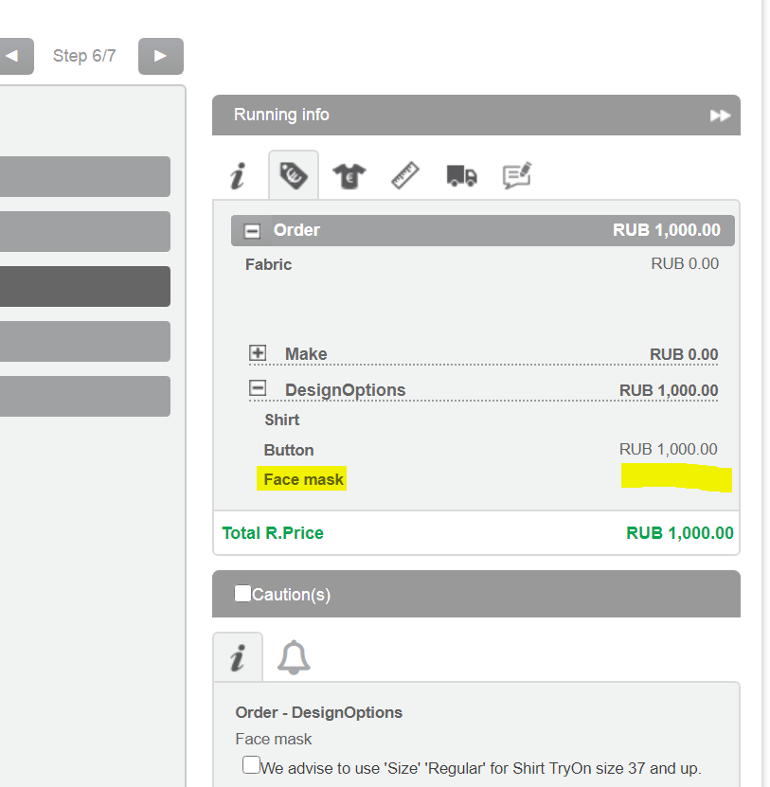

Screenshot of a single facemask.

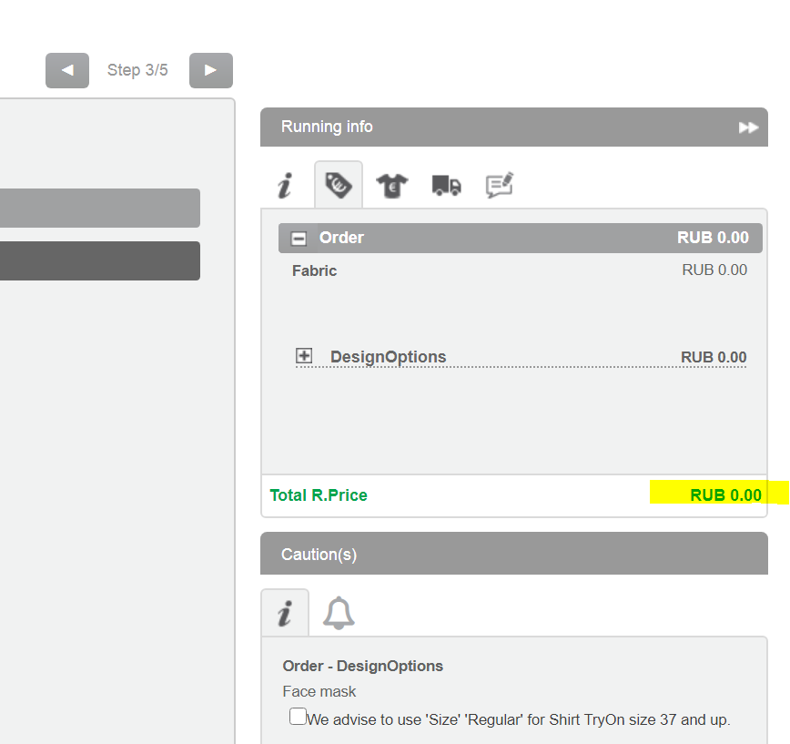

P.price is showing, but R.price is not. Customer informed us they always upload R,prices and adjust when needed, but I could not make an export from system as it was to big to check.

Screenshot of Pricing overview in shop, no price is showing at Shirt+Facemask and Singel Facemask option, just took an example as I was not able to get an export from system.

