# AM procedure how to link labels

With linking labels and hangtags there are various steps to follow. Please find below explanation.

Create shop label: go into admin.  
**Go-create -> shops -> shop labels -> shop labels -> add shop labels**

Click on ‘’Add shop label’’  
**Fill in all mandatory fields.**

*Please note:

* Shop label name is something you create yourself
* Production code is the code you will have to request from Irene.

*Please find on the next page a visual explanation

* The below explanation can be followed for the below listed ateliers;  
- Suits   
- Shirts  
- Overcoat  
- MIT   
- HMIT

- Ties

**Shop label overview**

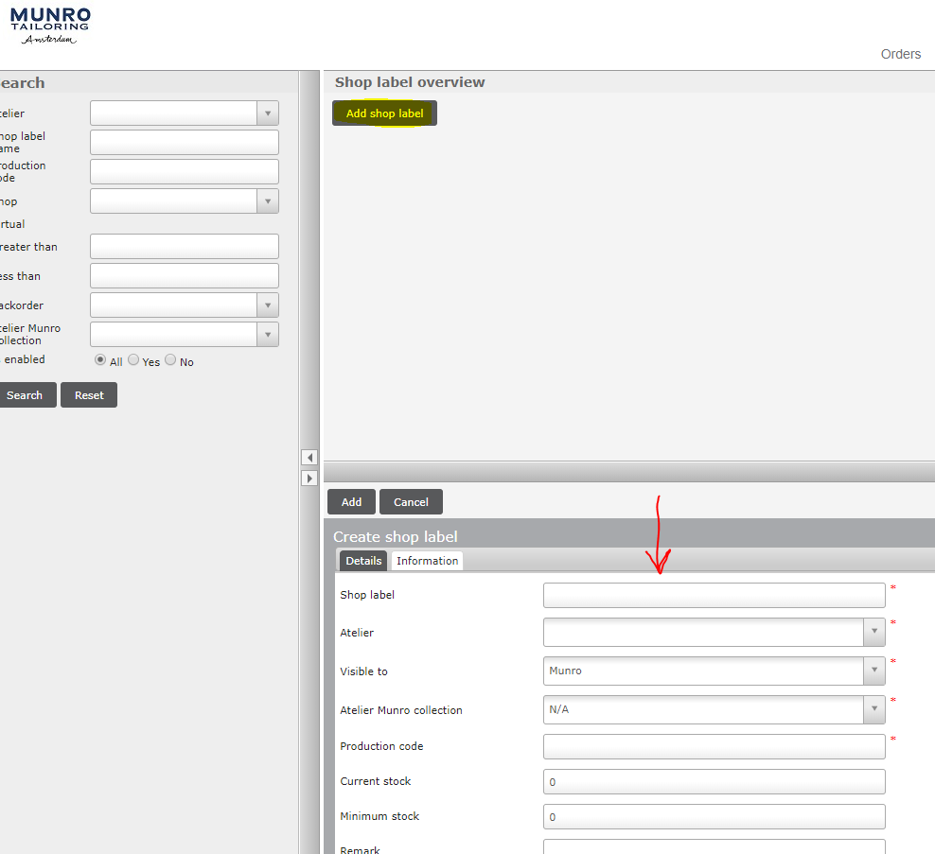

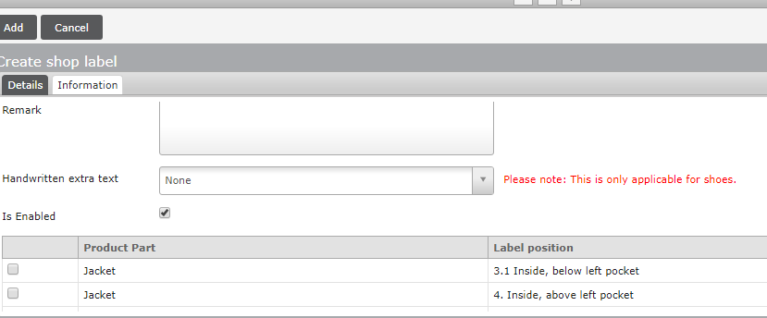

|  |  |  |
| --- | --- | --- |
| **Actions** | **Remarks** | **Example** |
|  |  |  |
| Shop Label | Create a clear distinctive name | Clements & Church Suits Purple label |
| Atelier | Choose the correct atelier | * Suits  * Munro blue  * Ties |
| Visible to | Choose always Munro | Munro |
| Atelier Munro collection | N/A | N/A |
| Production code | The code received from Irene | Clements 1 |
| Current stock | The amount of labels received | 2100 |
| Minimum stock | The min amount of labels reached when a label needs to be requested at a partner | This is depending on the weekly sales of the partner |
| Remarks | Date, initials, action taken | 18-10-2019, RM, New label (re-stock) |
| Handwritten extra text | N/A |  |
| Enable | Make sure the box is ticked |  |
| Choose label position | Check label position option on harddrive |  |

**How to link the label to a shop**

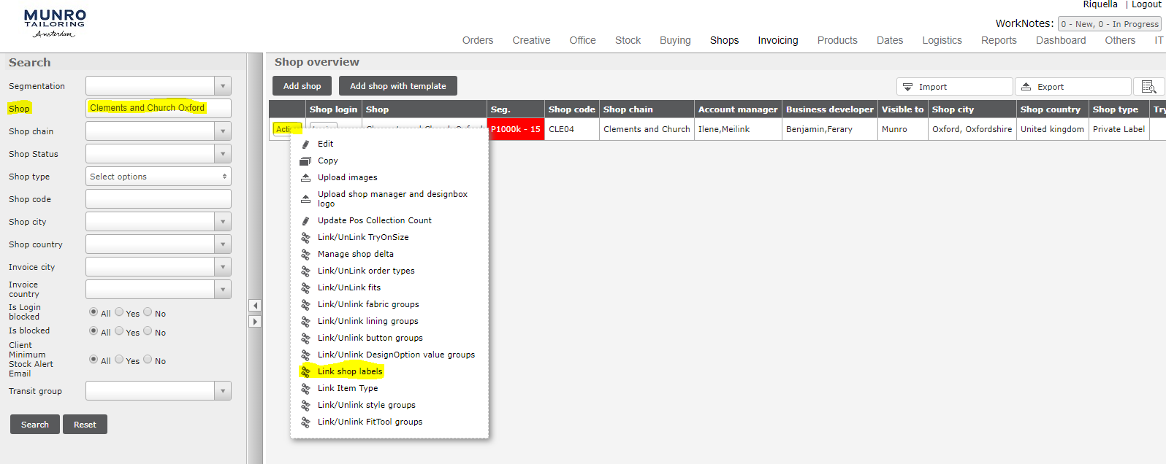

|  |  |  |
| --- | --- | --- |
| **Actions** | **Remarks** | **Example** |
| Shop | Enter the shop name | Clements & church |
| Search |  |  |
| Action |  |  |
| Link shop labels |  |  |

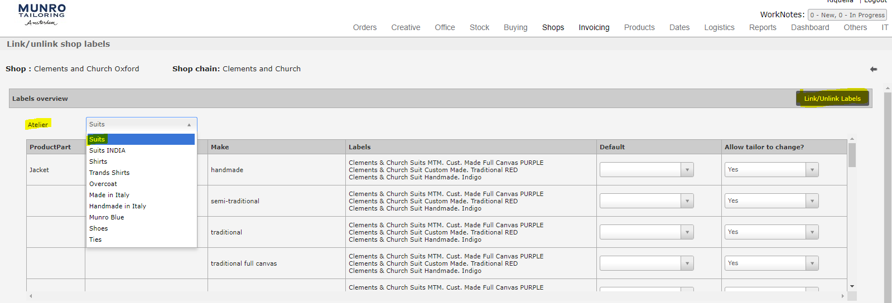**You’re now in the linking portal**

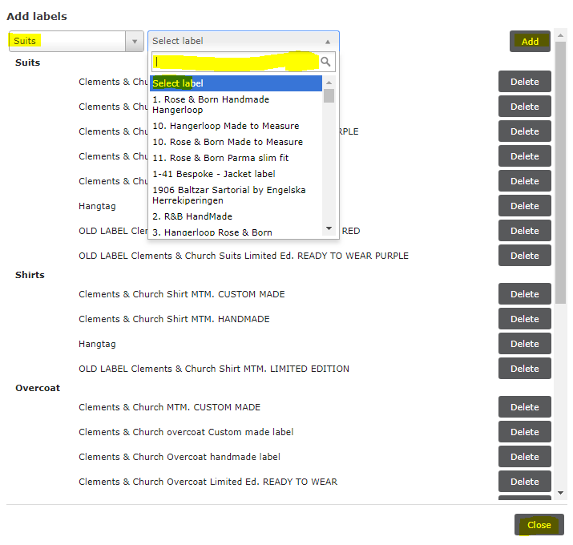

|  |  |  |
| --- | --- | --- |
| **Actions** | **Remarks** | **Example** |
| Atelier | Select the correct atelier | Suits |
| Click on link/ unlink labels |  |  |
| Add labels | Choose the correct atelier |  |
| Select label | Search on the just created shop label name | Clements & Church Suits Purple label |
| Click on Add |  |  |
| Click on Close | Label is added, there isn’t a save button |  |

**Explanation default setting (not mandatory)**

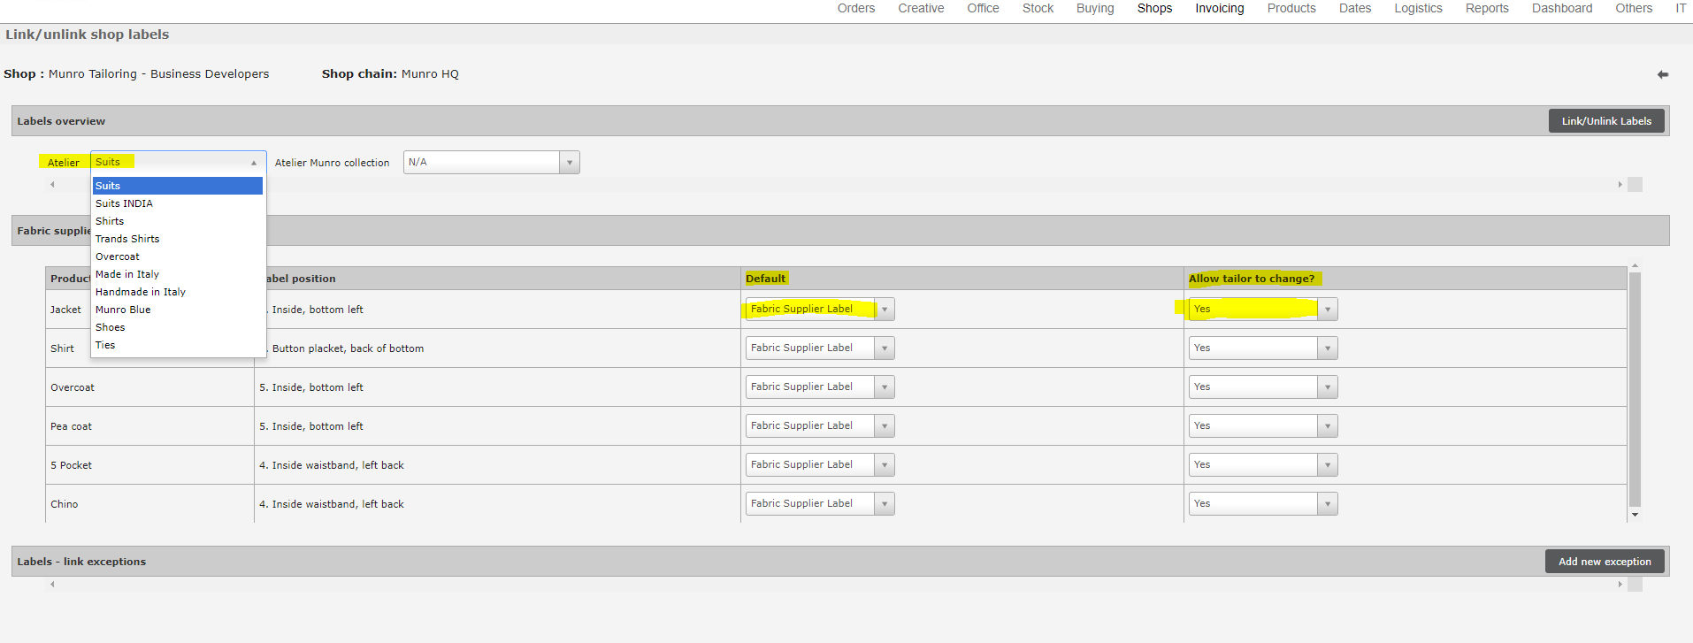

*Creating a default setting is optional.

If the partner always want a certain label in the garment. There are two option:  
- Create a **default** setting, with the possible to change the label or even to NO label. Advantage of this option is that the tailor can’t forget to select a label in the process.  
- Use the possibility to **allow tailor to change** to NO.  
this means the label is automatically linked at the back end, with no option to change this while entering an order.   
Advantage of this option is to prevent orders coming in without a label.

- When clicking allow tailor to change yes, this gives the tailor the possibility to change the label.