**Labels: 25% production project**When we are starting up the 2nd suit atelier in India, the client label management is not going to be more easy.   
To make sure we are not running out of stock in 1 of the 2 ateliers we need to improve the current client stock management in go-create.    
  
**1-** **Shop “POP-UP” message client label “low” or “out of stock”> applicable for all ateliers except Shoes Stamps.**

* Current label settings in admin

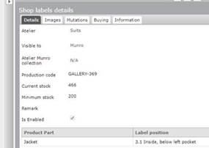

* As soon the label stock QTY will go below the minimum stock level the message  
   *“*Please note, shop labels are low in stock with our atelier*”* will show on the moment the label is selected in the branding section of the order creation.   
  (label will stay in the selected field)
* DE: Bitte beachten Sie, dass die Shop-Etiketten in unserem Atelier nur wenig auf Lager sind.
* EN: *Please note, shop labels are low in stock with our atelier*
* NL: Let op, de voorraad van labels is laag bij ons atelier

FR: Veuillez noter que le stock des étiquettes de votre boutique est très bas dans notre atelier.

* As soon the label stock QTY  is “0” the following message will show:  
  *“Please note, shop labels are no longer available, so you will receive your garment without a shop label.*” on the moment the label is selected in the branding section of the order creation.   
  (label will disappear in label selection as soon the “OK” is selected)
* DE: Bitte beachten Sie, dass die Shop-Etiketten nicht mehr verfügbar sind, Sie erhalten Ihre Aufträge ohne Shop-Etiket.
* EN: Please note, shop labels are no longer available, so you will receive your garment without a shop label
* NL: Let op, labels zijn niet meer beschikbaar, u ontvangt uw order zonder label.
* FR: Veuillez noter que vos étiquettes sont en rupture de stock, vous recevrez donc votre vêtement sans l’étiquette de votre boutique.  
    
  During order creation it will show as follow:

* Active / non-active button for this popup for bigger accounts.   
    
  In Admin “Shop labels details” will have active / non-active button, please see below marked in yellow.

This button we can use for clients for which we (Munro) is responsible for the stock level. (Atelier Munro shops, key accounts etc.)

* Same warning will also show in the Caution(s) message in the order creation as above, what need to be selected on the end of the order creation.
* For shops that have the branding information as default will not receive a pop-up message during order creation, however they will see in the Caution(s) message and need to be selected there to finalize the order.
* For the 2 “suit” atelier, system will take the stock information from atelier in which the order is created.
* When label stock is “0”in admin the label will not show any more on the production order sheet. This is the case at the moment and very confusing for Ateliers because we ask them to make an order for witch the materials are not available.

**2-weekly sales indicator in Shop Labels Details to understand stock level> applicable for all ateliers**

* For AM it’s more easy to know when shops will start running out of stock to have a sales indicator in the “shop labels details”.  
  This number will tell them how many of this label was used over the last 10 weeks.

**3-Enabled/ Disabled button functionality > applicable for all ateliers**

If label is put on “Is Enabled“ in the shop it stays visible in the branding section of the ordercreation.

If this tick box is selected, label must be automaticly unlinked from shops and not be anymore selectable in the shop(s).

If this tick box is selected, also in the export files this labels must **NOT** show anymore.

Needs to work like the “inactive“ button we also have on several places in admin.

Also, if a shop is deactivated, it is automatically unlinked from enabled labels.

add “shop is active / inactive” in Shop label overview.

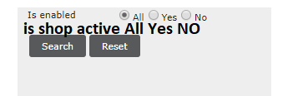

**4-Label photo export including production code per atelier. applicable for all ateliers**

To have good overview for production which labels are now in use we need a new export in the system. This excel overview is now made manual by AM/Product team, and then not necessary anymore.

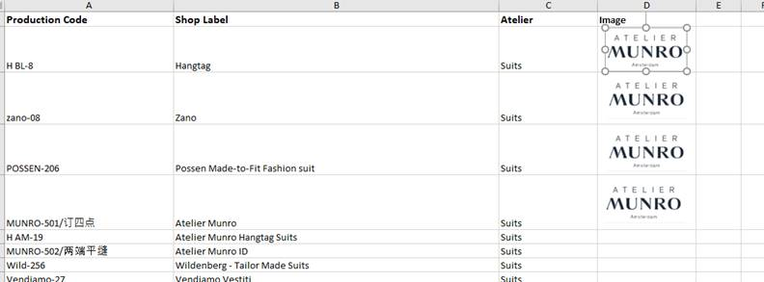

**5-New Shop label in go create creation > applicable for all ateliers**

-In the creation of a label in admin the Min Stock must be mandatory field to add when creating the labels. It cannot be zero value.

-We need admin for helping to create the production code as follow ( only for NEW labels after the release):

**For suits/ Suits India/Coats/Shirts**

Digit 1 :

* H -> hangtag
* L -> Label
* R -> hanger loop or Ribbon

Digit 2-3-4:

* ~~“Shop code” same ordernr 1~~~~st~~ ~~3 digits~~

~~Digit 5-6-7:~~

Shop code > typed by AM?

* Label description decided by AM

Digit 8-9-10:

Unique sequence number made by admin:  
we need to start from last used number! As the sequence is already started for existing labels > to be communicated closer to release date.  
Done by go go create

Done by AM ( typed)

It will be then as follow:

H-RRO-BK-037

L-RRO-WT-139

R-ROS-PK-22  
  
**For MIT / HMIT**  
Digit 1 :

* H -> hangtag
* L -> Label

Digit 2-3-4:

* “Shop code” same ordernr 1st 3 digits

Digit 5-6-7:

* “MU” ( this stays for Munro at atelier)

Digit 8-9-10:  
Unique sequence number made by admin:  
we need to start from last used number! As the sequence is already started for existing labels > to be communicated closer to release date

H-RRO-MU-037

L-RRO-MU-139

**For Pants**  
Digit 1 :

* H -> hangtag
* L -> Label
* B -> backpatch

Digit 2-3-4:

* “Shop code” same ordernr 1st 3 digits

Digit 5-6-7:

* “Label description decided by AM

Digit 8-9-10:

Unique sequence number made by admin:  
we need to start from last used number! As the sequence is already started for existing labels > to be communicated closer to release date   
  
H-RRO- WT -037  
L-RRO- WT -139  
BP-RRO- WT -139

**For Shoes**  
Stamp description decided by AM ( free digits! No max qnty)  
Unique sequence number made by admin:

we need to add sequence to existing shoes stamp;  
then new ones will start from last used number!   
Ettemadis -01  
  
**Ties**

Digit 1-2-3:

* “Shop code” same order nr 1st 3 digits

Digit 4-5 :

* T -> Ties
* PS -> PocketSquare
* BT -> Bowtie

Digit 6-7-9:   
Unique sequence number made by admin: **NB! Sequence is per Ties / PocketSquare / Bowties.**  
then new ones will start from last used number!

OGER-PS-02, next PS is PS03, Ties T01

Checking this > product part

Check with ties

**6-solution for the combination labels. > applicable for all ateliers except shoes > check with Jouko!**

Goal: single label stock- able , but appear in HTML on same position.

-more labels can be linked to same atelier and position  
-button “ combination label: “Yes / No” in Shop Label Details.   
if “Yes” > drop down menu with all the Enabled labels linked to this shops for this atelier.  
multiple choices can be selected.  
  
-In HTML the combinations will appear on the same position divided by “/”:  
main label / combination labels ( see below chart)  
Remark for Marcia: label 1 must be created first

-Add search option in Shop labels overview “ Is combination: Yes / “No””

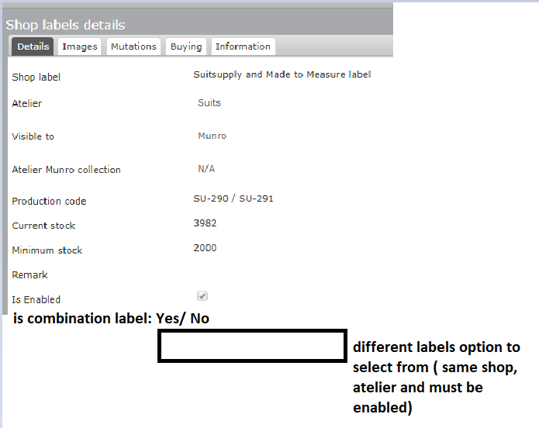



These are the existing combinations in admin, with stock details and what should appear on HTML.  
Stock info will be more accurate closer to release date!

**SUITS**

|  |  |  |  |  |
| --- | --- | --- | --- | --- |
| **Label code** | **stock** | **Combination Yes / No** | **1st Label** | **On HTML** |
| **LUTZ-34** | 0 | No |  |  |
| **Blue-476** | 700 | Yes | LUTZ-34 | LUTZ-34 & Blue-476 |
| **Handmade-53** | 950 | Yes | LUTZ-34 | LUTZ-34 & Handmade-53 |
| **Light-474** | 850 | Yes | LUTZ-34 | LUTZ-34 & Light-474 |
| **Royal-475** | 750 | Yes | LUTZ-34 | LUTZ -34 & Royal-475 |
| **SIGNATURE-500** | 2150 | No |  |  |
| **TRADI-505** | 8250 | Yes | SIGNATURE-500 | SIGNATURE-500 / TRADI-505 |
| **SIGNATURE-499** | 8250 | No |  |  |
| **TRIM-519** | Yes | SIGNATURE-499/ TRIM-519 | SIGNATURE-499 | SIGNATURE-499/ TRIM-519 |
| **full-239** | 848 | Yes | SLFMD-101 | SLFMD-101 & FULL-239 |
| **SLFMD-101** | 4550 | No |  |  |
| **SU-290** | 5500 | No |  | SU-290 / SU-291 |
| **SU-291** | 5500 | Yes | SU-290 | SU-290 / SU-291 |

**SHIRT**

|  |  |  |
| --- | --- | --- |
| **Lable code** | **stock** | **On HTML** |
| Lutz-61 | 1684 | Lutz-61 & Handmade-158 |
| Handmade-158 | 914 | Lutz-61 & Handmade-158 |
| **hangtags code** | **stock** | **On HTML** |
| SP-3 | 6000 | SP-3 / SP-2 |
| SP-2 | 5800 | SP-3 / SP-2 |

**SUITS INDIA > Raju to check if this is applicable as for Moss the process is different.**

|  |  |  |
| --- | --- | --- |
| **Lable code** | **stock** | **On HTML** |
| **Moss-228** | 25439 |  |
| **Regular-387** | 19608 | **Moss-228/Regular-387** |
| **Skinny-388** | 19153 | **Moss-228/Skinny-388** |
| **Tailored-386** | 15517 | **Moss-228/Tailored-386** |

**7-Remove the label attachment tool, this is not used anywhere.**

This we built for the ELBA project but never used after.

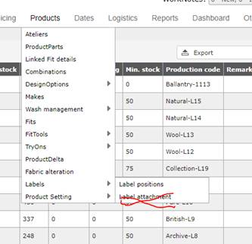

**8-add “translation” option in Shop Label Details.**if something is added, it will appear next to the shop label in HTML.  
( same as Design Option functionality).

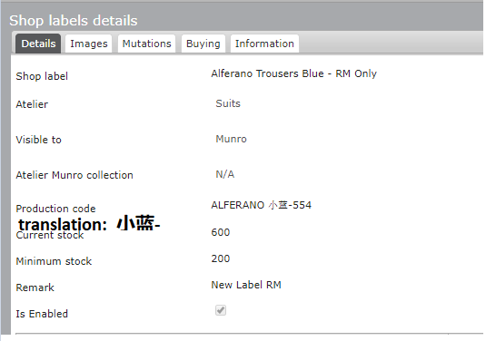

Chinese translation must be removed from these labels and copied in “Translation” shop settings.  
Only for Suits ( china).

|  |  |  |
| --- | --- | --- |
| **Label code** | **New label code after IT changes** | **On HTML** |
| **M+BB-530/两端平缝** | **M+BB-530** | **M+BB-530/两端平缝** |
| **ALFERANO大灰-551** | **ALFERANO-551** | **ALFERANO -551/大灰** |
| **ALFERANO 大绿-555** | **ALFERANO-555** | **ALFERANO -555/大绿** |
| **ALFERANO 大蓝-553** | **ALFERANO -553** | **ALFERANO -553/大蓝** |
| **ALFERANO 大黑-549** | **ALFERANO -549** | **ALFERANO-549/大黑** |
| **ALFERANO小灰-552** | **ALFERANO -552** | **ALFERANO -552/小灰** |
| **ALFERANO 小绿-556** | **ALFERANO -556** | **ALFERANO -556/小绿** |
| **ALFERANO 小蓝-554** | **ALFERANO -554** | **ALFERANO -554/小蓝** |
| **ALFERANO 小黑-550** | **ALFERANO -550** | **ALFERANO -550/小黑** |
| **M+BB-528/订四点** | **M+BB-528** | **M+BB-528/订四点** |
| **M+O-524/订四点** | **M+O-524** | **M+O-524/订四点** |
| **M+O-525/两端平缝** | **M+O-525** | **M+O-525/两端平缝** |
| **MUNRO-501/订四点** | **MUNRO-501** | **MUNRO-501/订四点** |
| **MUNRO-502/两端平缝** | **MUNRO-502** | **MUNRO-502/两端平缝** |

**9-Double labels ( same label different collections / product part**possibility of linking same label to more collections and positions and same stock;  
at the moment AMs have to create 2 codes with fake stock and this cannot continue.

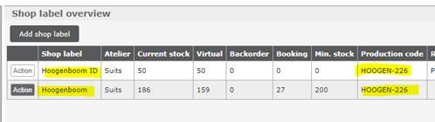

|  |  |  |  |
| --- | --- | --- | --- |
| **AM** | **Production Code** | **Shop Label** | **Current Stock** |
| Atelier Munro,AM | VELTMAN-460 | Veltman Liesting Suit | 3145 |
| Atelier Munro,AM | VELTMAN-460 | Veltman Liesting Suit ID | 1005 |
| Atelier Munro,AM | HARRY-174 | Harry Rosen CA00572 Suits | 3886 |
| Atelier Munro,AM | HARRY-174 | Harry Rosen CA00572 Suits CM | -72 |
| Atelier Munro,AM | HARRY-174 | Harry Rosen CA00572 Suits ID | 0 |
| Atelier Munro,AM | HOOGEN-226 | Hoogenboom ID | 14 |
| Atelier Munro,AM | RAUM-587 | Raum suit grey label | 392 |
| Atelier Munro,AM | RAUM-587 | Raum suit grey label ID | 99 |
| Riquella | CONSIGLIERI-11 | Consiglieri | 4392 |
| Riquella | CONSIGLIERI-11 | Consiglieri Cluj | 4538 |
| Riquella | SIGNATURE-499 | Nordstrom Main label waistcoat | 3995 |
| Riquella | SIGNATURE-499 | Nordstrom Suit main label Sportcoat | 3985 |
| Yvonne Spee | HOOGEN-226 | Hoogenboom | 306 |
| Yvonne Stoer | JV-512 | John Varvatos - hangerloop | 46 |
| Yvonne Stoer | JV-512 | John Varvatos - trousers | 45 |



After the above points are implemented:

**10- IT to copy all Suits labels into Suits India atelier**

-              Need to create the label export file china to make the label import file for India. IT can do this from back-end: both production codes and Shop Label names will be the same, also positions etc.

- pictures will be uploaded by AMs for China and copied by IT into India.