**Hi All,**

**We hereby have a request to implement the following within the system for Suitsupply.**

**Request:**

* **Make option to mark order as wedding order mandatory in the system**

**Reason:**

* **We would like to group orders in our system, so wedding and normal orders are more visible**

**How:**

1. **At the end of the order page shops are now able to mark the order *“Urgent/Wedding order”* see below screenshot.**

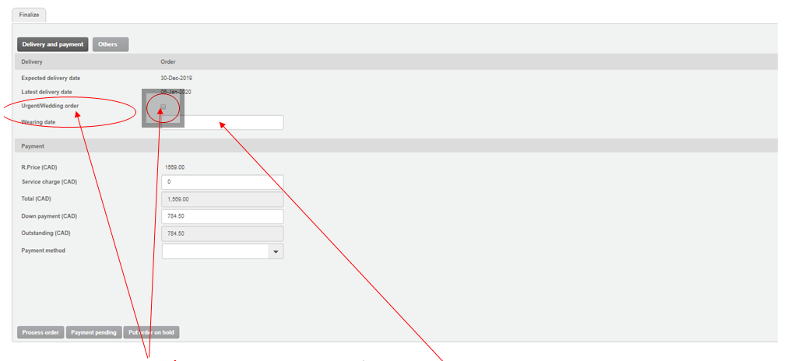

1. **We would like to have the *“Urgent/Wedding order”* option moved to the 1st pages, along with the option to add a *“Wearing date”***

***Example below:***

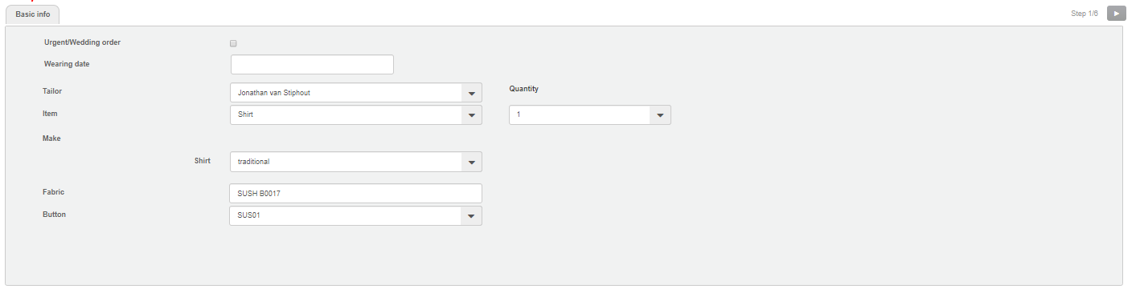

**Let’s plan a meeting to go over this to make sure it is all clear.**

**Kind regards**

**Marcia Gassman**