# AM procedure how to link labels Jeans

With linking labels and hangtags there are various steps to follow. Please find below explanation.

Jeans and Chino’s:The customer is able to have 2 different ‘’labels’’: a main label and a backpatch. If the customer doesn’t have the wish to have a personalized backpatch, then the blank backpatch will be used, which you can find in admin under ‘’Made in Italy’’ at show label overview.

Create shop label: go into admin.  
**Go-create -> shops -> shop labels -> shop labels -> add shop labels**

Click on ‘’Add shop label’’  
**Fill in all mandatory fields.**

*Please note:

* Shop label name is something you create yourself
* Production code is the code you will have to request from Irene.

*Please find on the next page a visual explanation

* The below explanation can be followed for the below listed ateliers;  
- Jeans

- Ties

**Shop label overview**

How to link a Jeans (5 pocket) Label:

Main label means a customized customer label (with logo of customer) which is possible to have inside waistband.

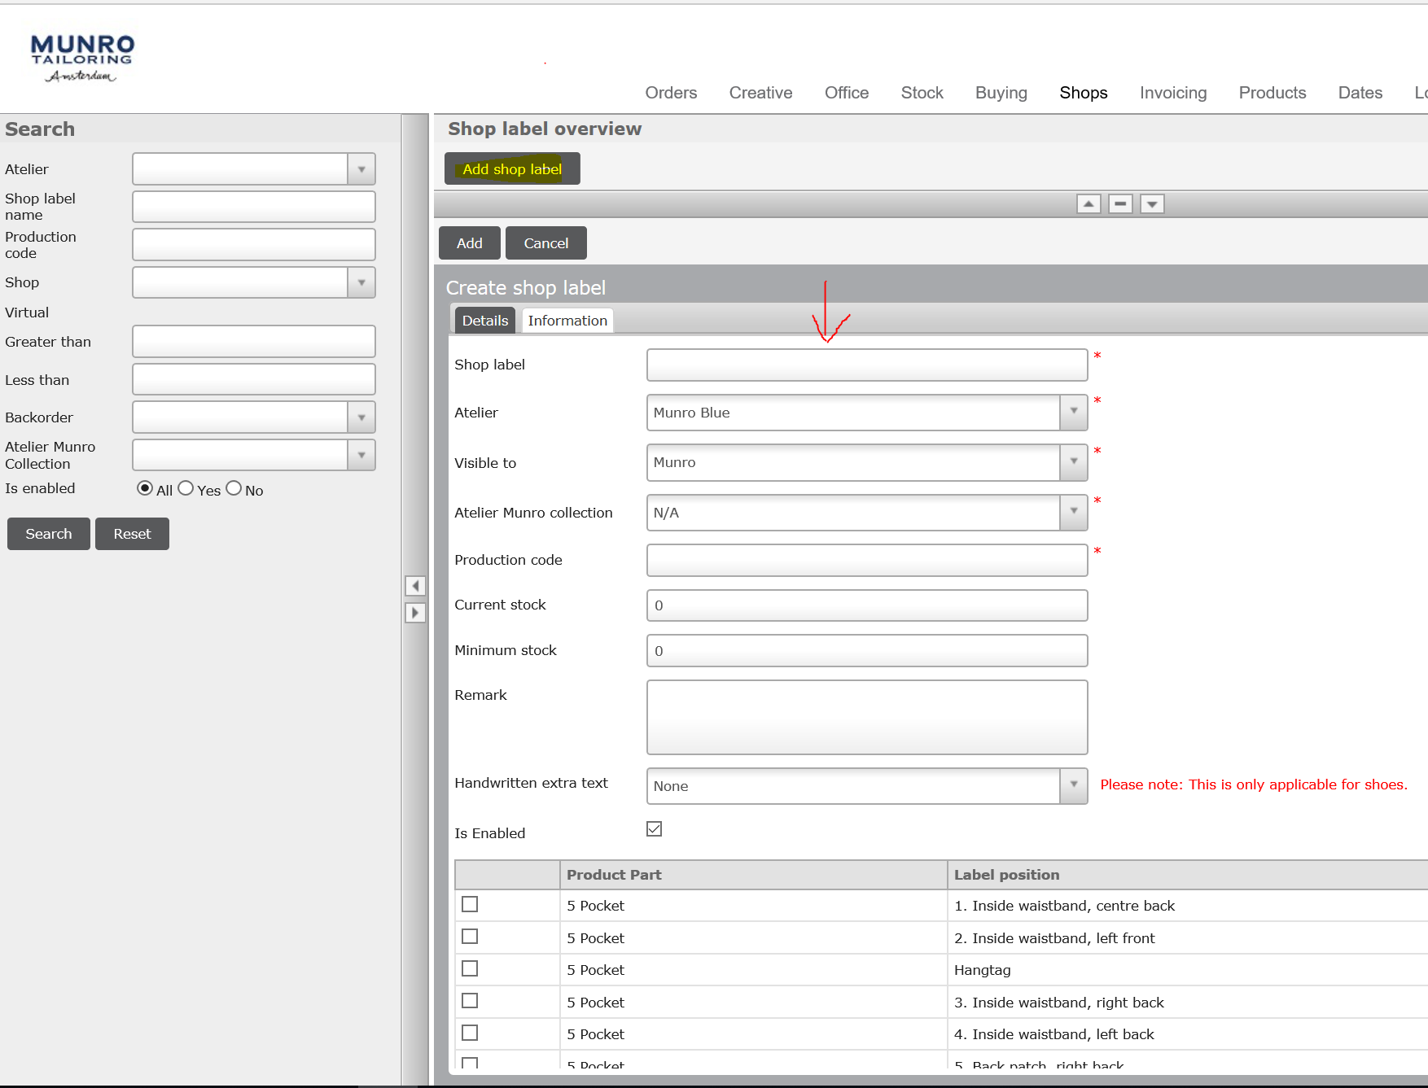

|  |  |  |
| --- | --- | --- |
| **Actions** | **Remarks** | **Example** |
| Shop Label | Create a clear distinctive name | Clements & Church Jeans label |
| Atelier | Choose the correct atelier which is Munro Blue | Munro Blue |
| Visible to | Choose always Munro | Munro |
| Atelier Munro collection | N/A | N/A |
| Production code | The code received from Irene | Clements 1 |
| Current stock | The amount of labels received | 2100 |
| Minimum stock | The min amount of labels reached when a label needs to be requested at a partner | This is depending on the weekly sales of the partner |
| Remarks | Date, initials, action taken | 18-10-2019, RM, New label (re-stock) |
| Handwritten extra text | N/A |  |
| Enable | Make sure the box is ticked |  |
| Choose label position | Check label position option on harddrive. | **Link your position for Jeans and double check if you need to link for the Chino as well** |

**Shop label overview**

How to link Backpatches:

A backpatch is a leather patch (available in several colours) which will be attached on the outside of the waistband.



|  |  |  |
| --- | --- | --- |
| **Actions** | **Remarks** | **Example** |
| Shop Label | Create a clear distinctive name | Clements & Church Jeans label |
| Atelier | Choose the correct atelier which is Munro Blue | Munro Blue |
| Visible to | Choose always Munro | Munro |
| Atelier Munro collection | N/A | N/A |
| Production code | The code received from Irene | Clements 1 |
| Current stock | The amount of labels received | 2100 |
| Minimum stock | The min amount of labels reached when a label needs to be requested at a partner | This is depending on the weekly sales of the partner |
| Remarks | Date, initials, action taken | 18-10-2019, RM, New label (re-stock) |
| Handwritten extra text | N/A |  |
| Enable | Make sure the box is ticked |  |
| Choose label position | 5. Back patch, right back | **Link your position for Jeans and double check if you need to link for the Chino as well** |

**How to link the label to a shop**

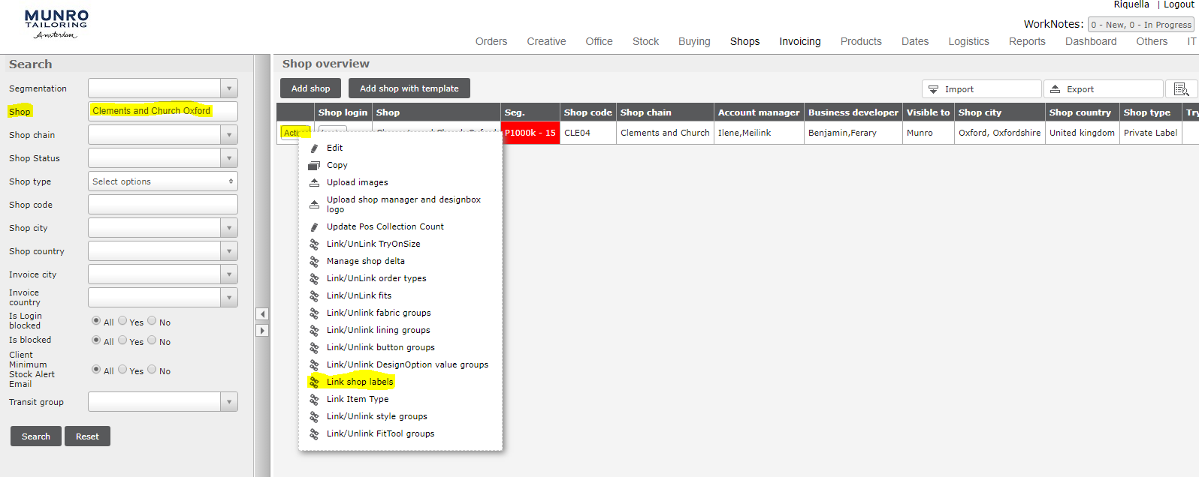

|  |  |  |
| --- | --- | --- |
| **Actions** | **Remarks** | **Example** |
| Shop | Enter the shop name | Clements & church |
| Search |  |  |
| Action |  |  |
| Link shop labels |  |  |

**You’re now in the linking portal**

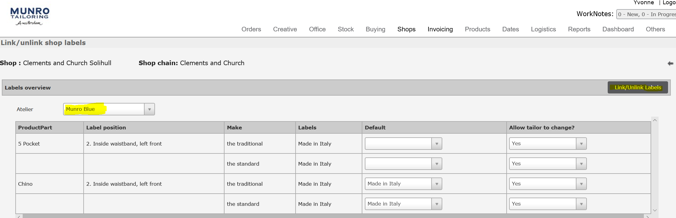

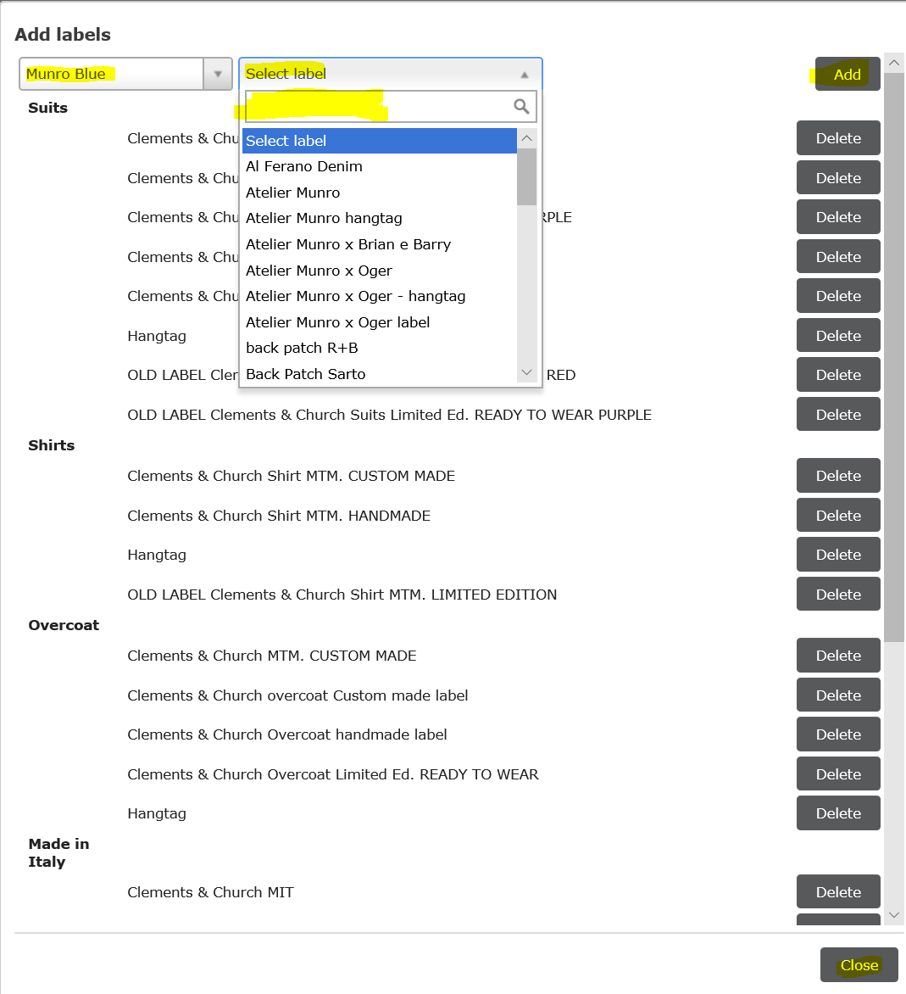

|  |  |  |
| --- | --- | --- |
| **Actions** | **Remarks** | **Example** |
| Atelier | Select the correct atelier | Munro Blue |
| Click on link/ unlink labels |  |  |
| Add labels | Choose the correct atelier |  |
| Select label | Search on the just created shop label name | Clements & Church Jeans label |
| Click on Add |  |  |
| Click on Close | Label is added, there isn’t a save button |  |

**Explanation default setting (not mandatory)**

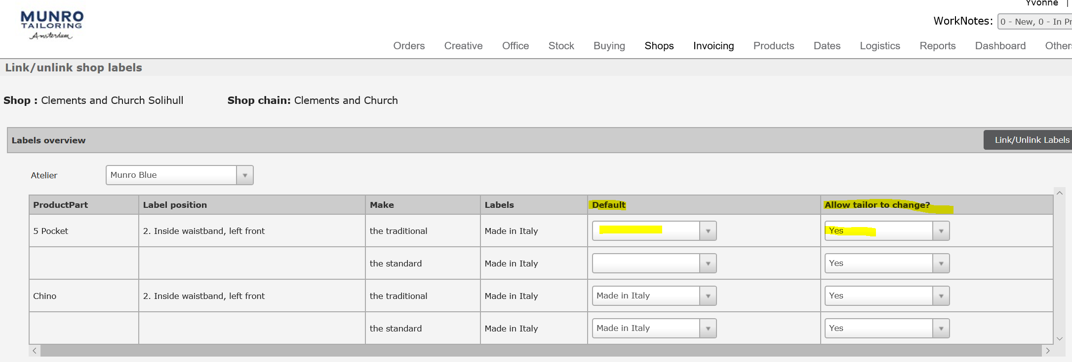

*Creating a default setting is optional.

If the partner always want a certain label in the garment. There are two option:  
- Create a **default** setting, with the possible to change the label/backpatch/hangtag or even to NO label. Advantage of this option is that the tailor can’t forget to select a label in the process.  
- Use the possibility to **allow tailor to change** to NO.  
this means the label/backpatch/hantag is automatically linked at the back end, with no option to change this while entering an order.   
Advantage of this option is to prevent orders coming in without a label/backpatch/hantag.

- When clicking allow tailor to change yes, this gives the tailor the possibility to change the label.

Important note for backpatch

Since 7-4-2019, When a customer has their own branded backpatch, the shop has to be linked to another ‘Design option value group’.

If this is not done, customers are able to select our blank patch, as well as their own, which basically is not possible.

So please activate the following Design option value group in a shop:

**PL - Jeans/ 5-Pockets** : For customers who do not have a branded back patch of their own. In this case in the design options the customer can select our available patches.

**PL - Jeans/ 5-Pockets (own back patch):** For customers who have their own back patch. In this case the design option ‘back patch’ is not visible and the customer can select their back patch in the customer label section.

Please could you double check and correct on customers who have added their own backpatch since 7-4-2019?

